create TABLE customers (customer_Id int NOT NULL,First_Name varchar(50) NOT NULL, Last_Name varchar(50) NOT NULL,phone varchar(50) NOT NULL, creditLimit decimal(10,2) DEFAULT NULL, PRIMARY KEY(customer_Id));

insert into customers(customer_Id,First_Name,Last_Name,phone,creditLimit)values(103,'Atelier','Schmitt','08-78966578','21000.00'),(112,'Signal','King','7025551838','71800.00'),(114,'Ferguson','Peter','03-9520 4555','117300.00'),(119,'Labrune','Janine','40.67.8555','118200.00'),(121,'Bergulfsen','Jonas ','07-989555','81700.00'),(124,'Nelson','Susan','4155551450','210500.00'),(125,'Piestrzeniewicz','Zbyszek ','(26) 642-7555','0.00'),(128,'Keitel','Roland','+49 6966 90 2555','59700.00'),(129,'Murphy','Julie','6505555787','64600.00'),(131,'Lee','Kwai','2125557818','114900.00'),(141,'Freyre','Diego ','(91) 555 94 44','227600.00'),(144,'Berglund','Christina','0921-12 3555','53100.00'),(145,'Petersen','Jytte ','31 12 3555','83400.00'),(146,'Saveley','Mary','78.32.5555','123900.00'),(148,'Eric','Jecob','+65 2217555','103800.00'),(151,'Young','Jeff','2125557413','138500.00');

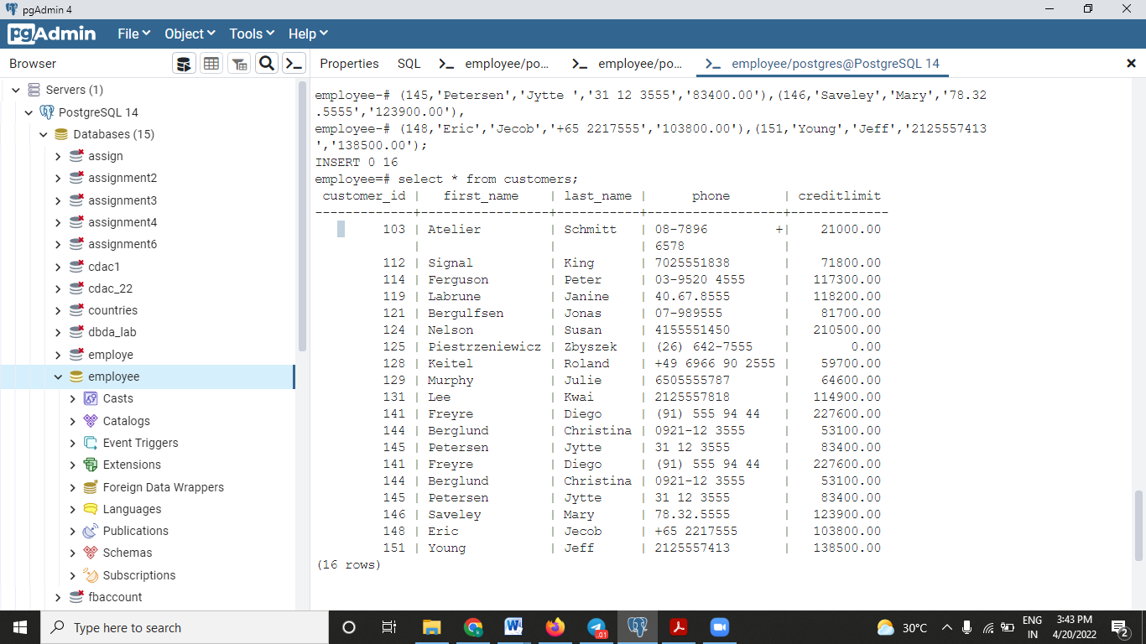

2.)

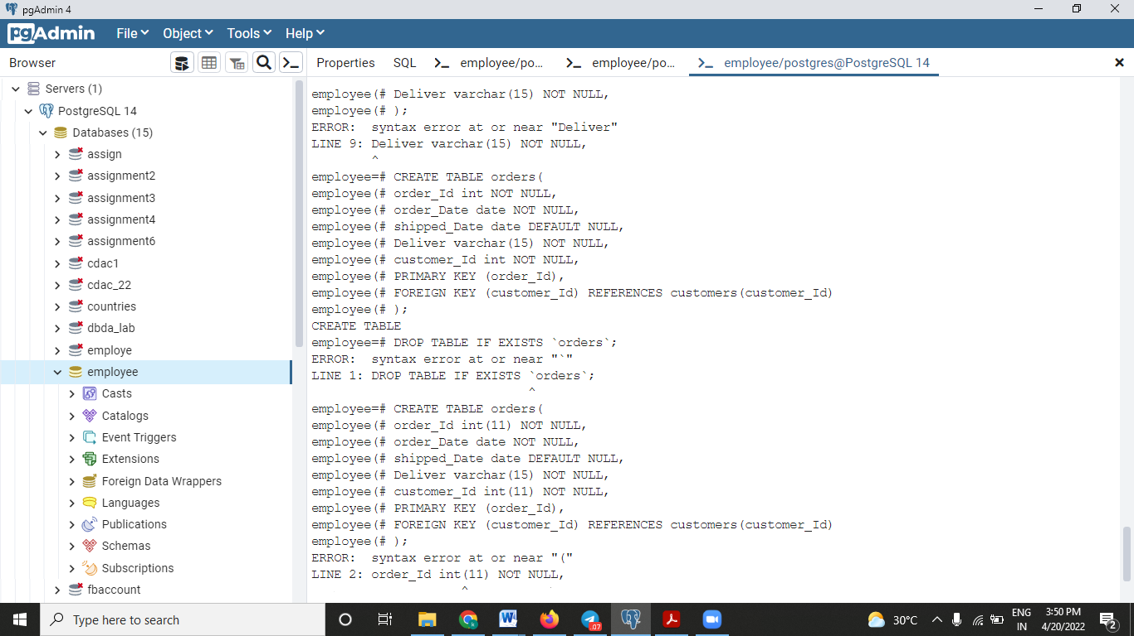

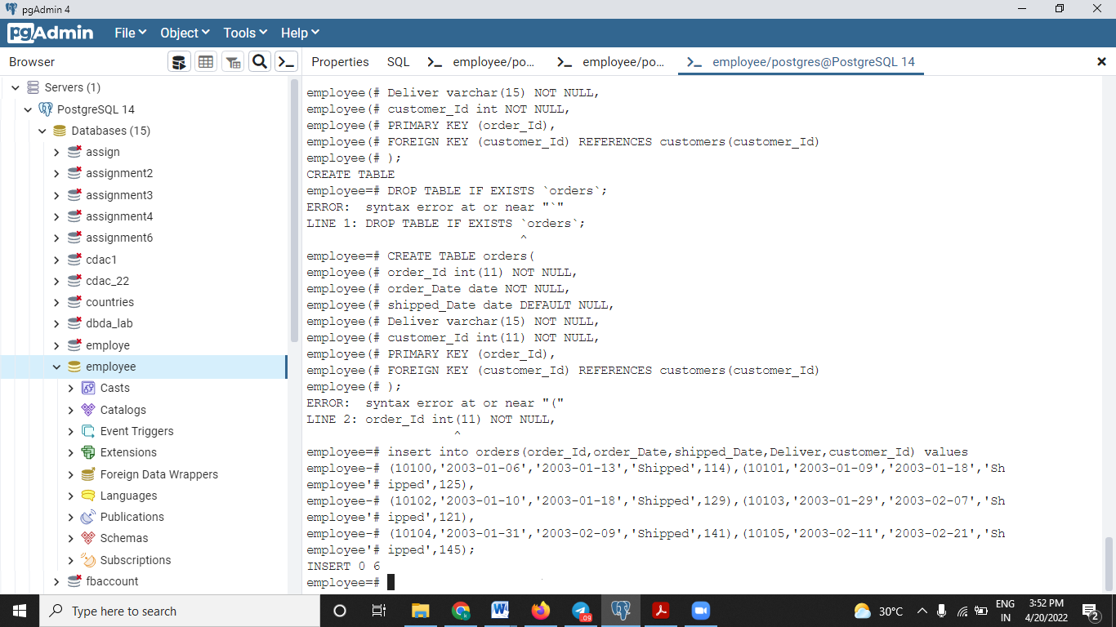

1. Write a Query to add a column package_stat to the table orders.

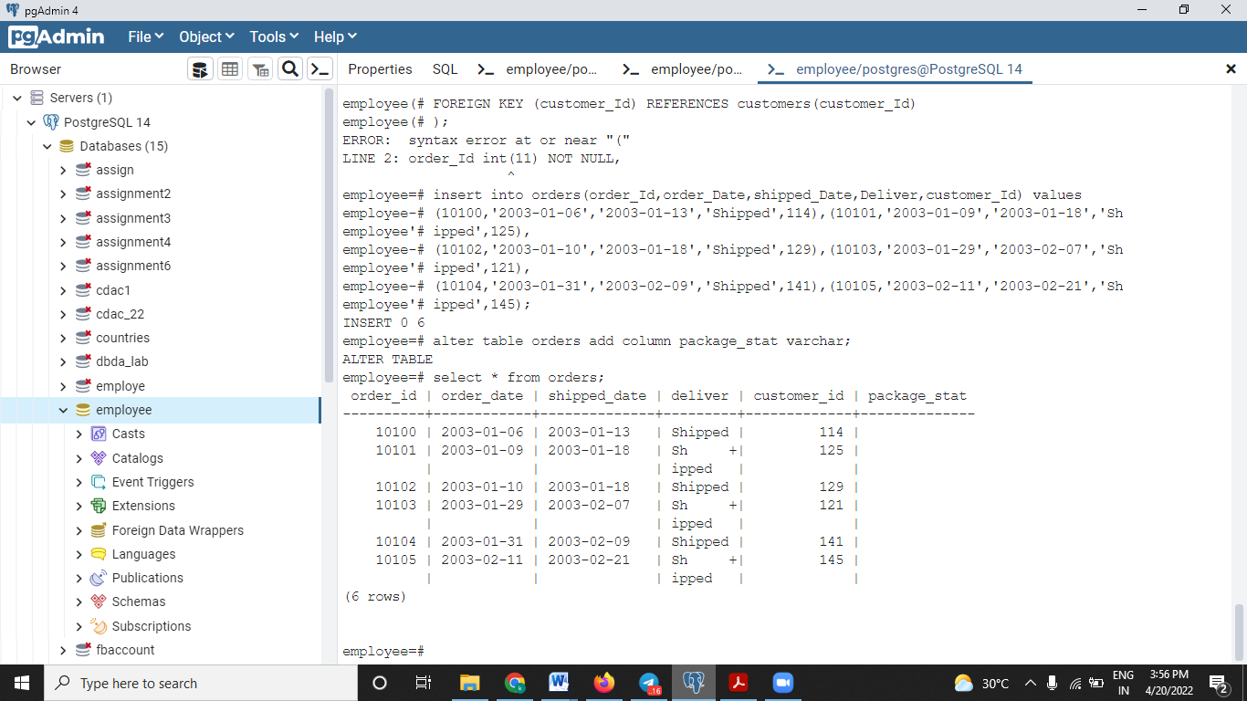

2. Write a Query to change the package_stat column of orders table with 'not available'

for all orders.

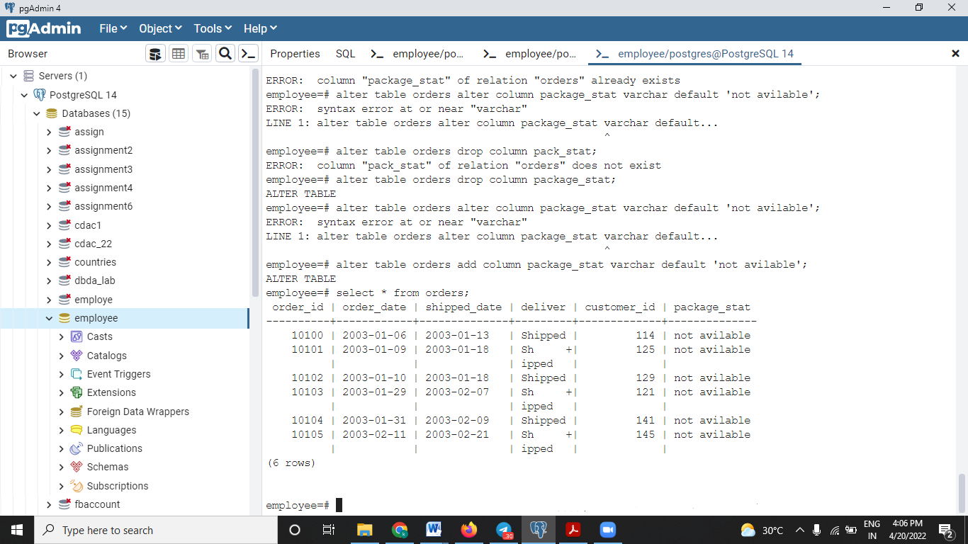

3.Write a Query to delete a row from customers table where credit_limit is 0.00

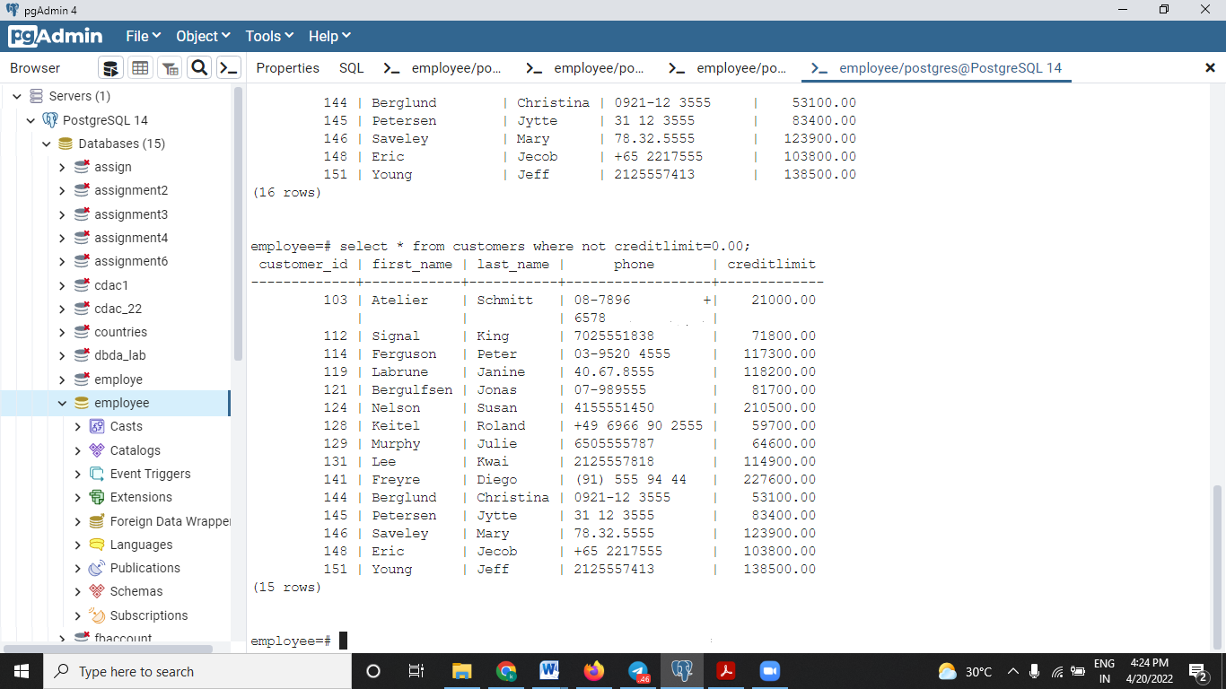

1. Write a Query to display the first_name with the occurrence of ‘el’ in the customers tables.

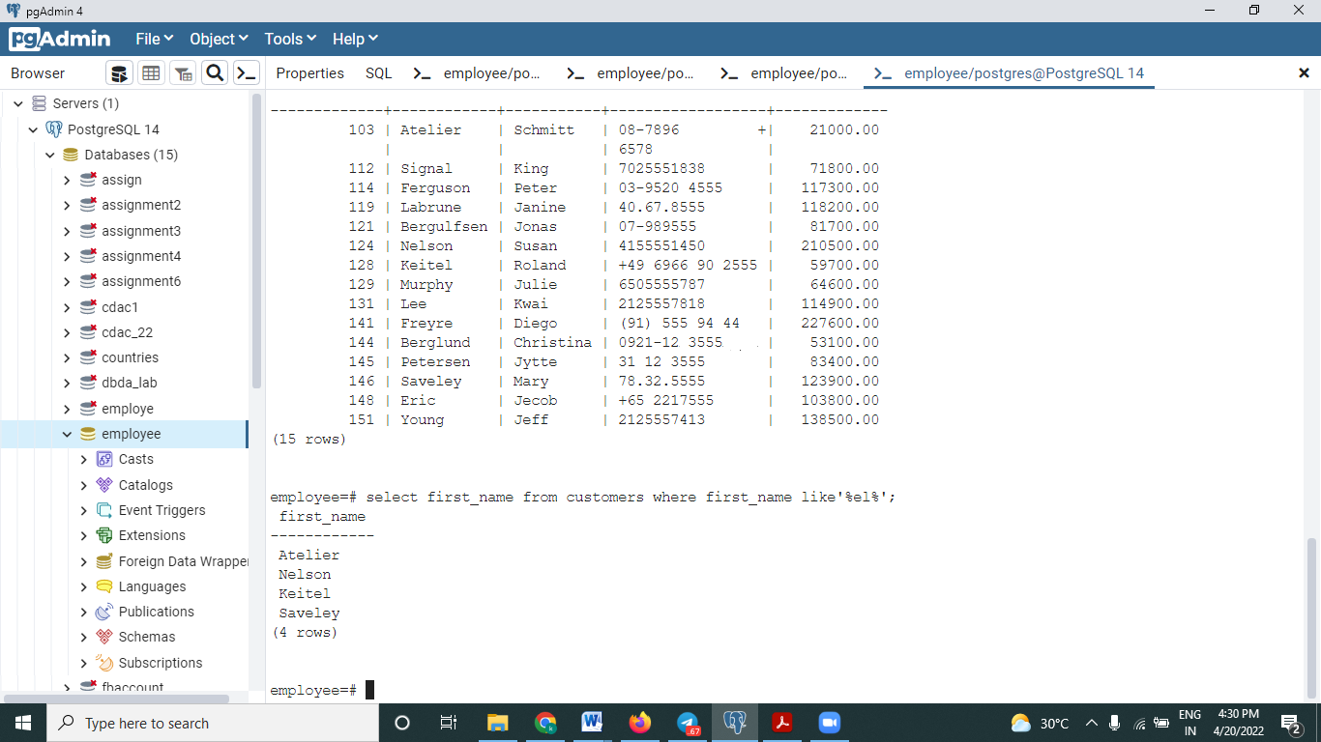

2. Write a Query to prepare a list with customer name ,customer_id ,order_id for the

customers whose delivery status is shipped.

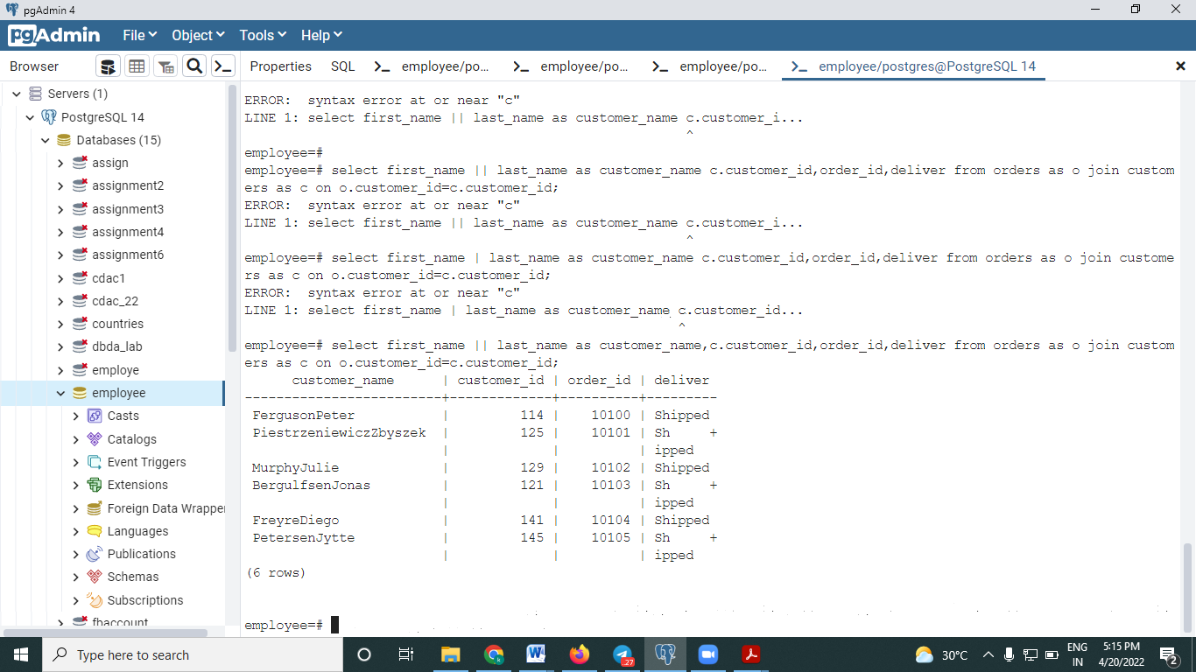

3.Write a Query to get the number of customers with the creditLimit greater than 50000.

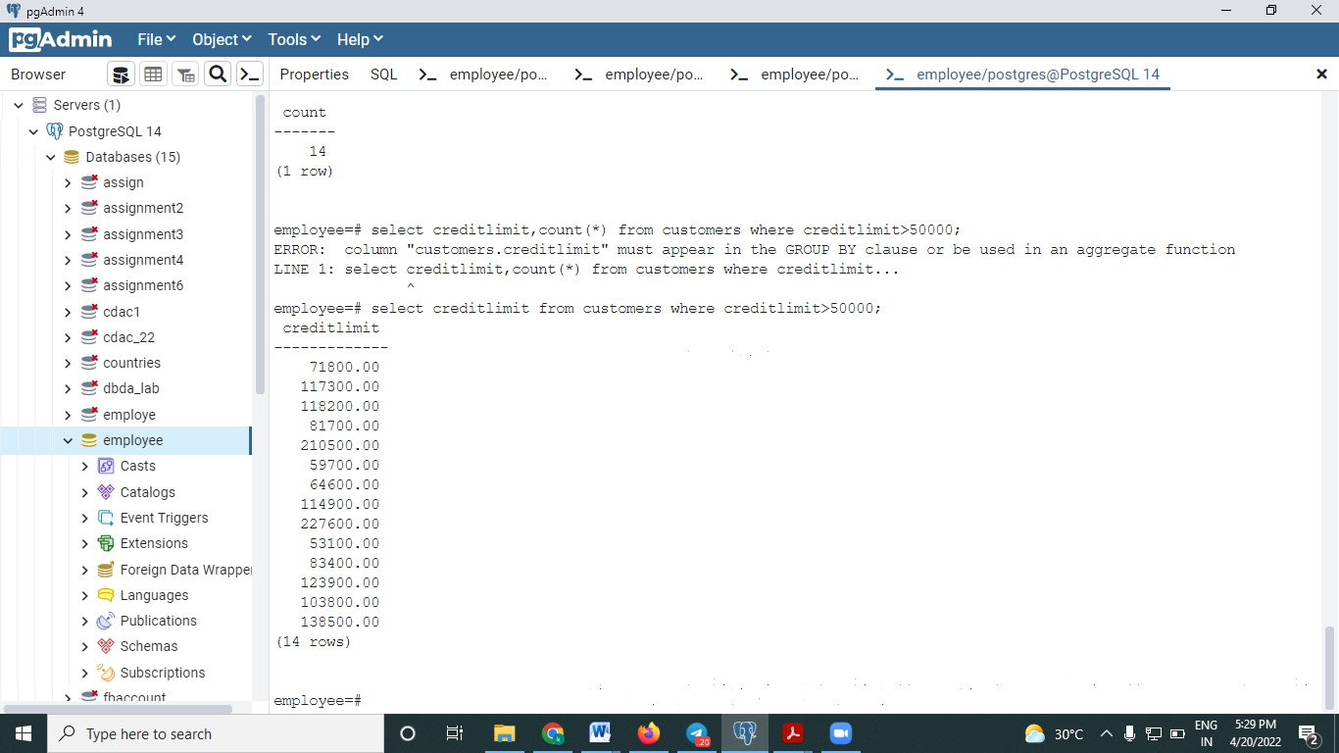

4. Write a Query to display the customer_id, name ( first name and last name ), order_id

and deliver for all customers.

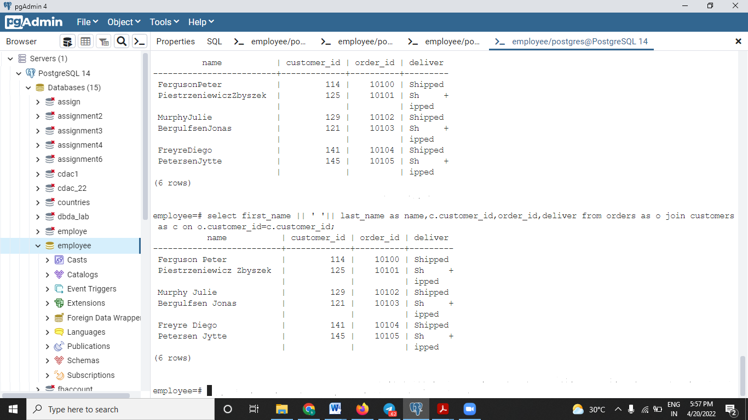

5. Write a Query to customer name in order of creditLimit smallest to highest.

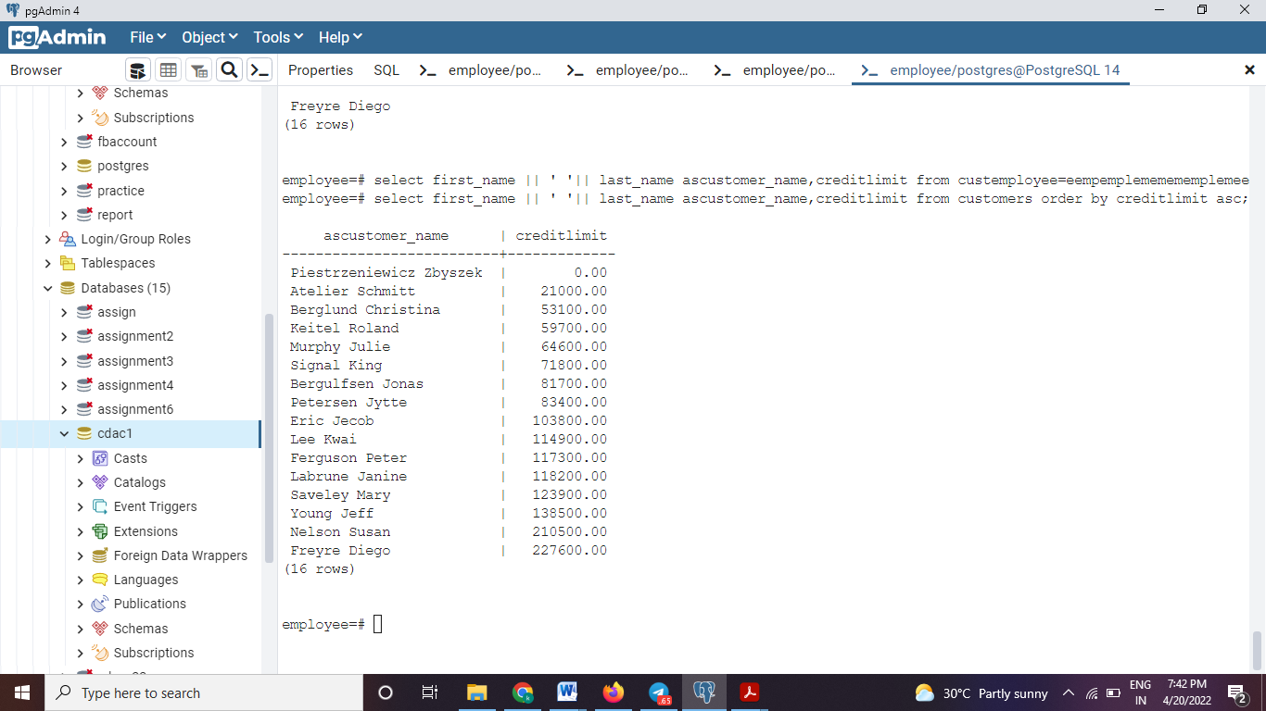

6. Write a stored procedure by name order_day. The procedure should show the

customer_id and the day on which he had made the order.

7. Write a stored function by the name of cutomer_search. The stored function should

return the maximum creditLimit made by any customer.

1. Create DEPT table with the following structure:-

DEPTNO INT(2)

DNAME VARCHAR (14)

LOC VARCHAR (13)

Insert the following rows in DEPT table:-

10, ACCOUNTING,NEW YORK

20, RESEARCH, DALLAS

30, SALES, CHICAGO

40, OPERATIONS, BOSTON

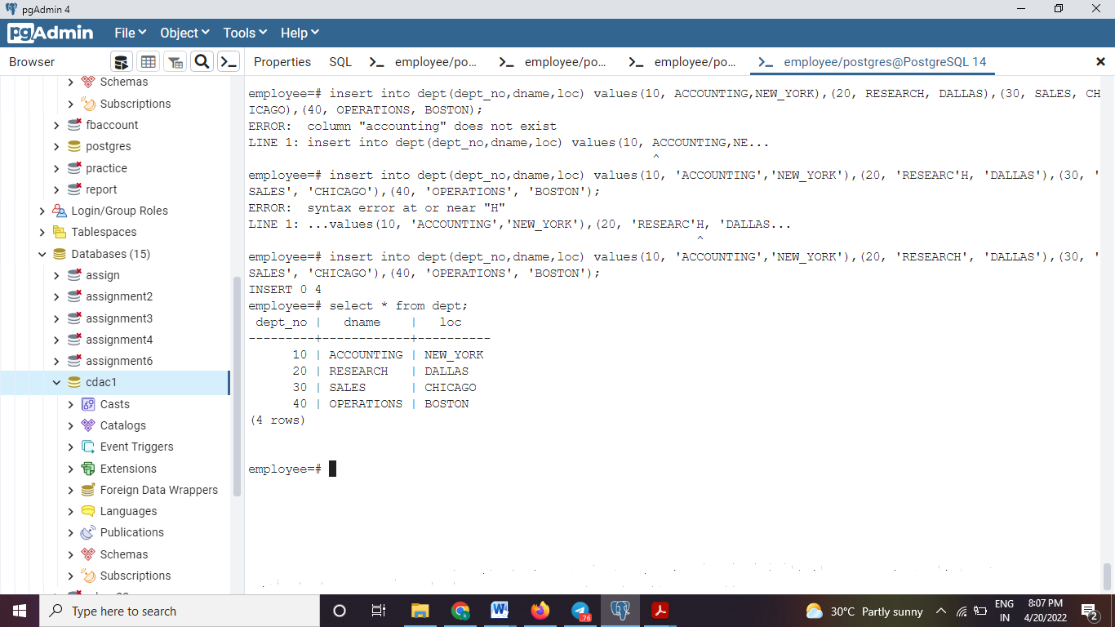

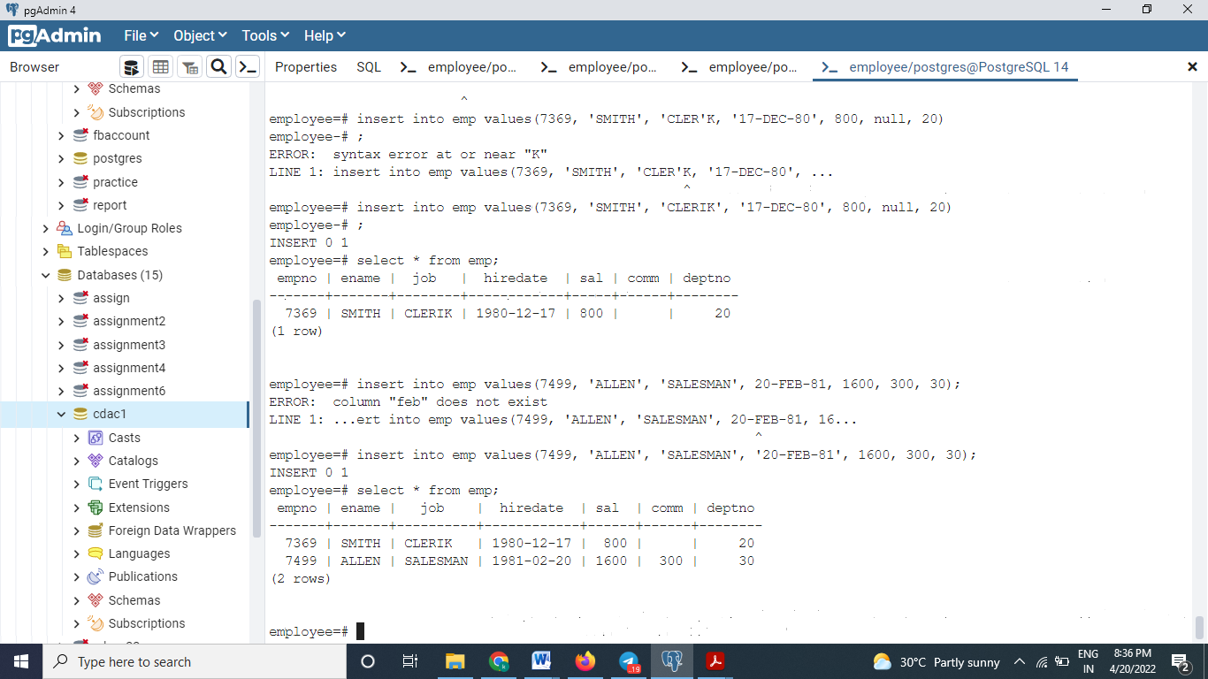

1. Create EMP table with the following structure:-
2. Display only the EMPNO and ENAME columns from EMP table.

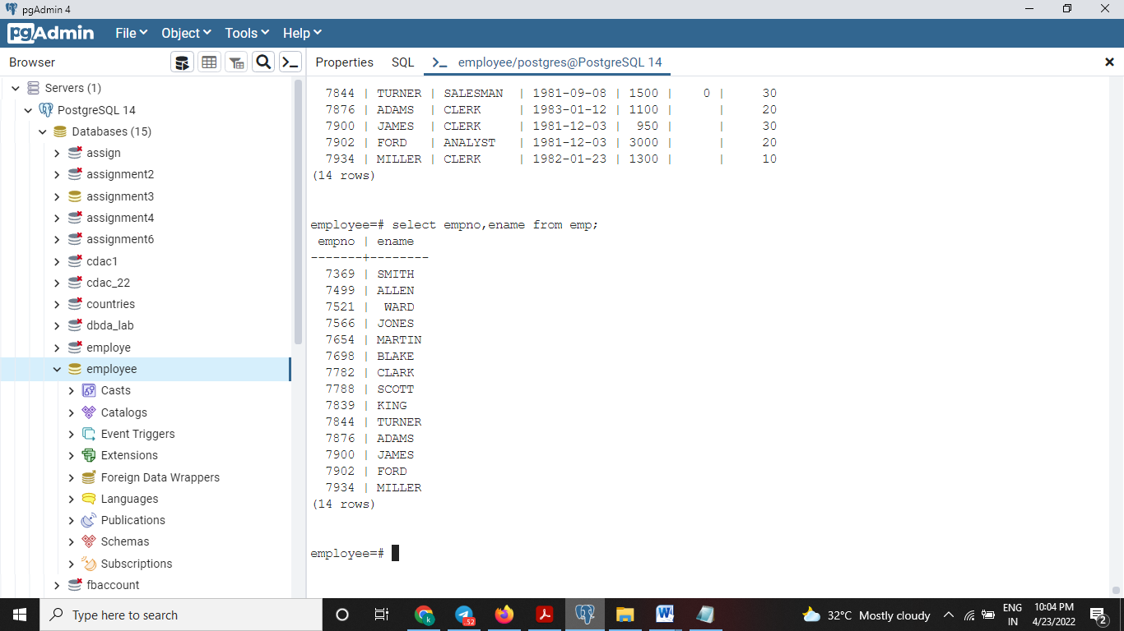

1. Display all employees who are CLERKs and the MANAGER.

--🡪 ilike -> ne capital ch small kas pn lihita yete.

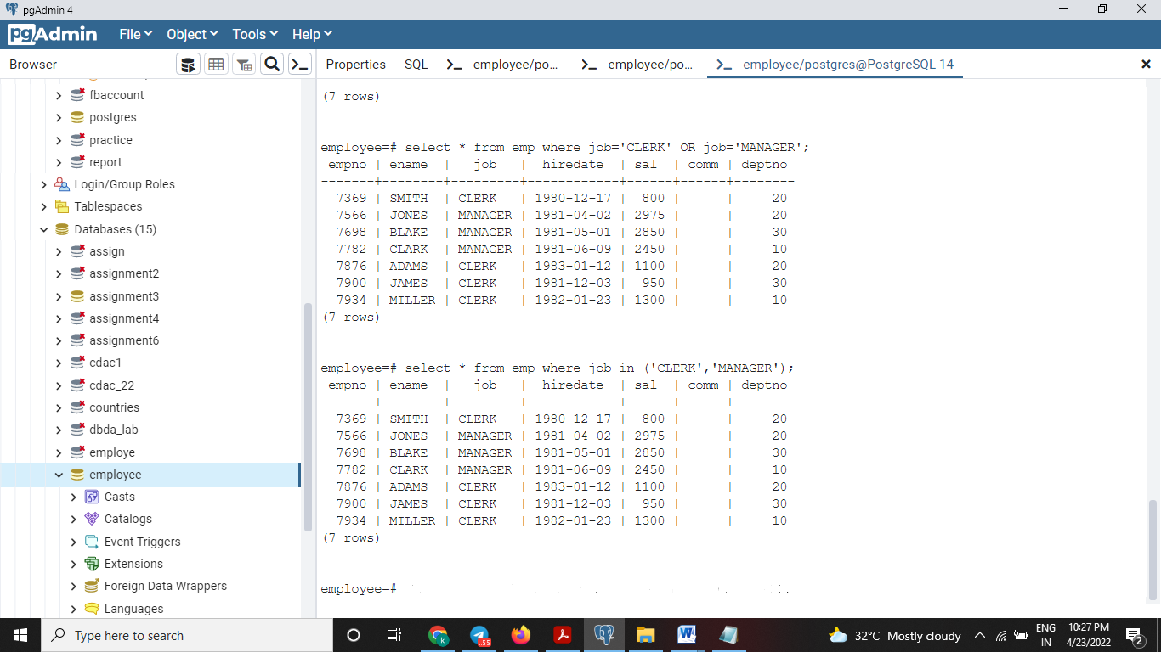

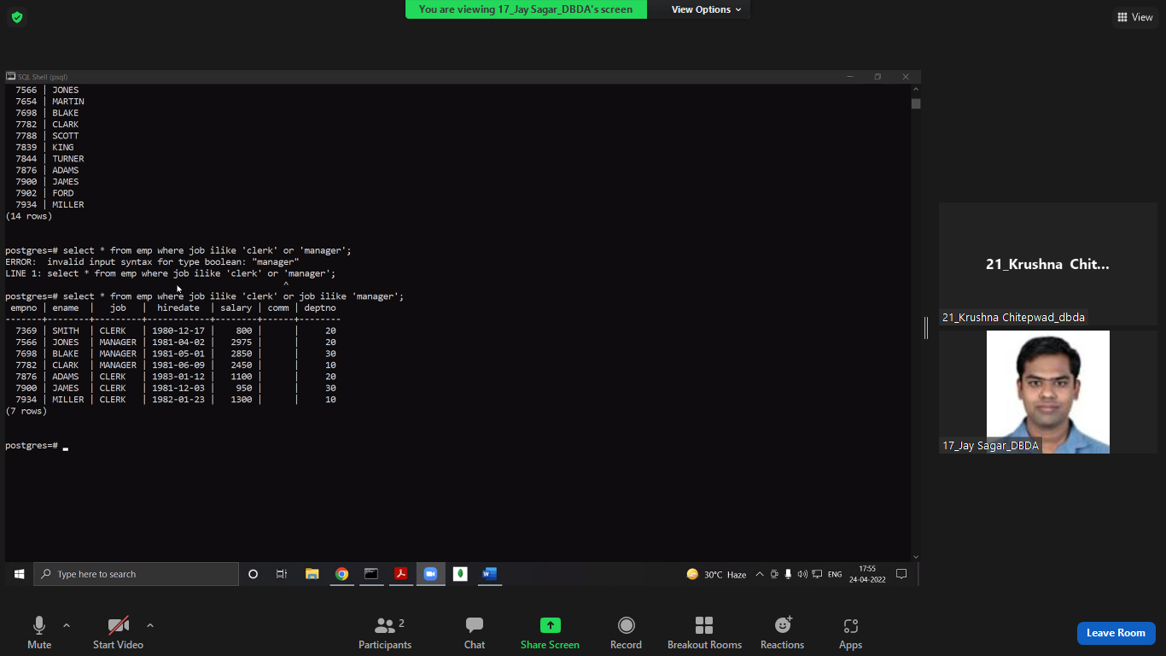

TWO METHOD NE KEL.

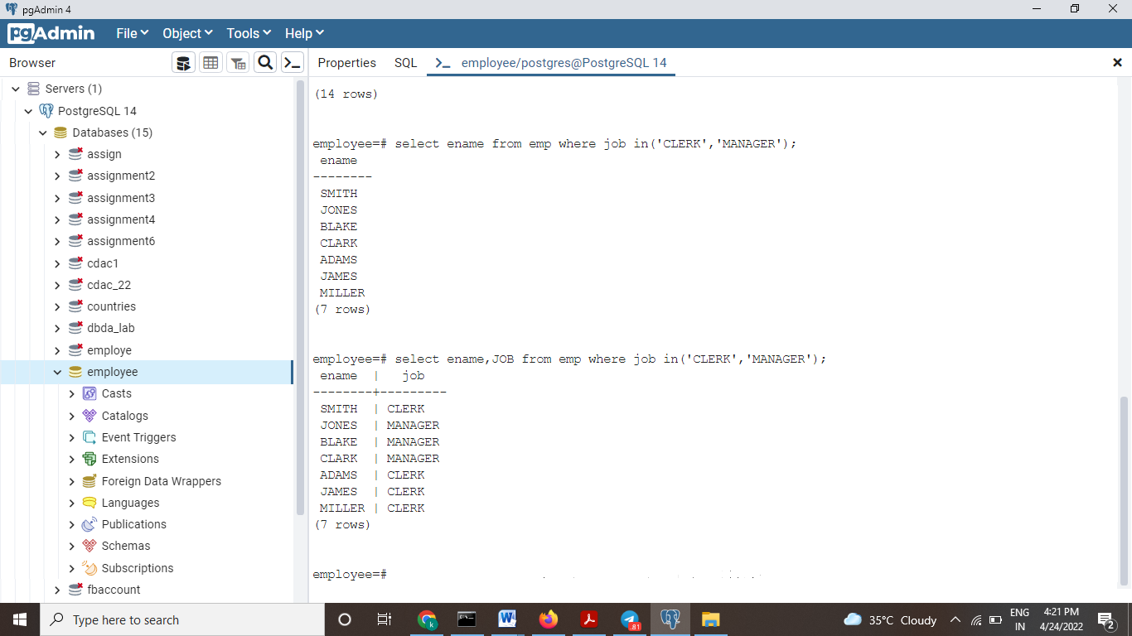

3. Display the ENAME and JOB for all employees who belong to the same DEPTNO as

employee ‘KING’.

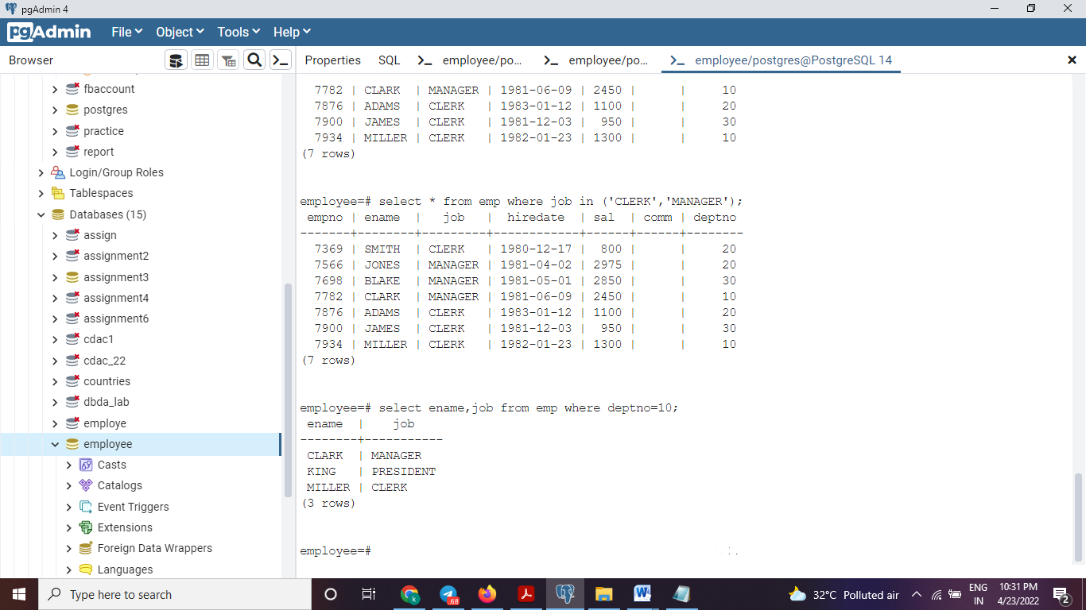

1. Find the names of all employees hired in the month of February (of any year).

select * from emp where to_char(hiredate, 'mon')= 'feb';

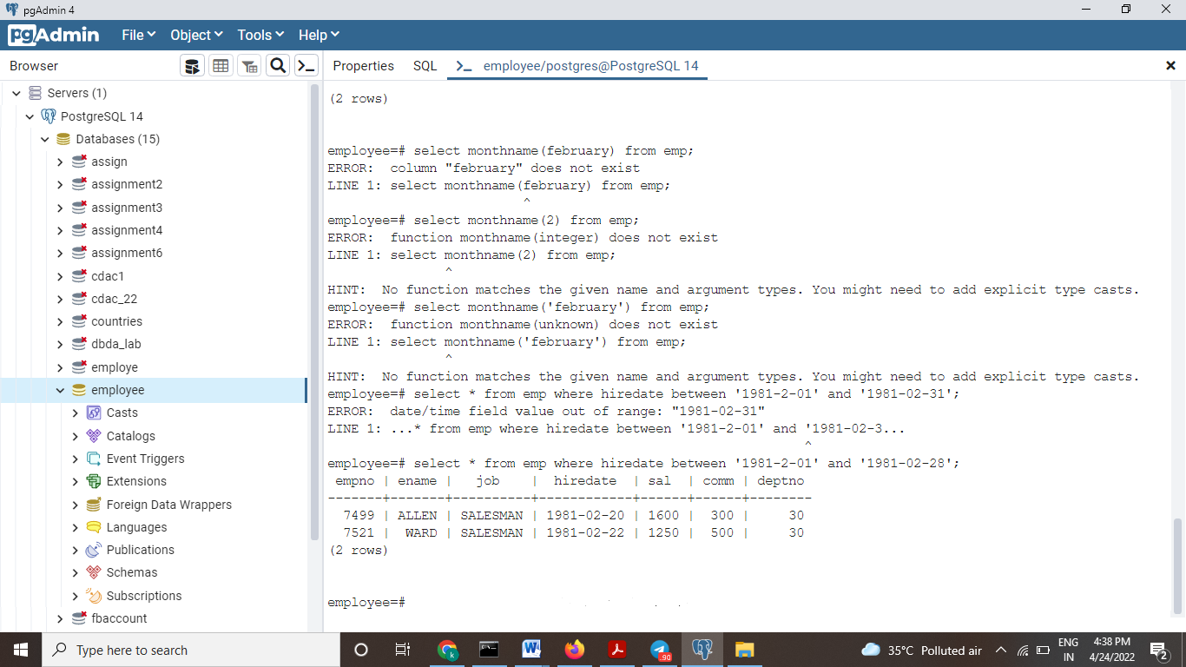

5. Display the employees in descending order of DEPTNO.

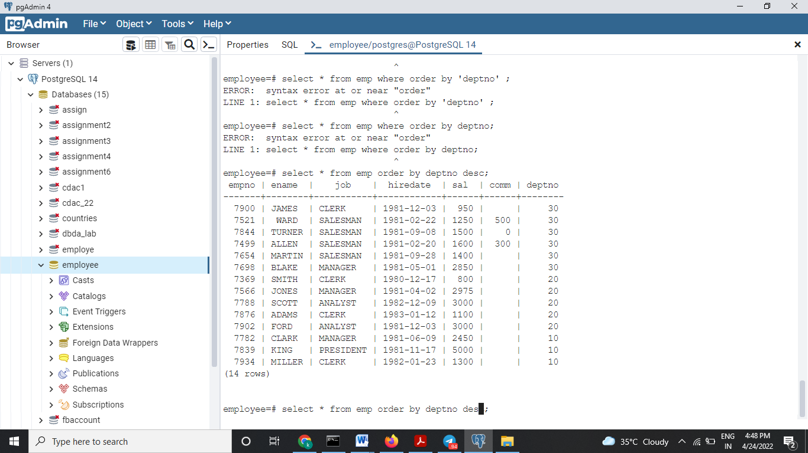

6. Display the employee name and employee number of the employees with the

headings as NUMBER and NAME

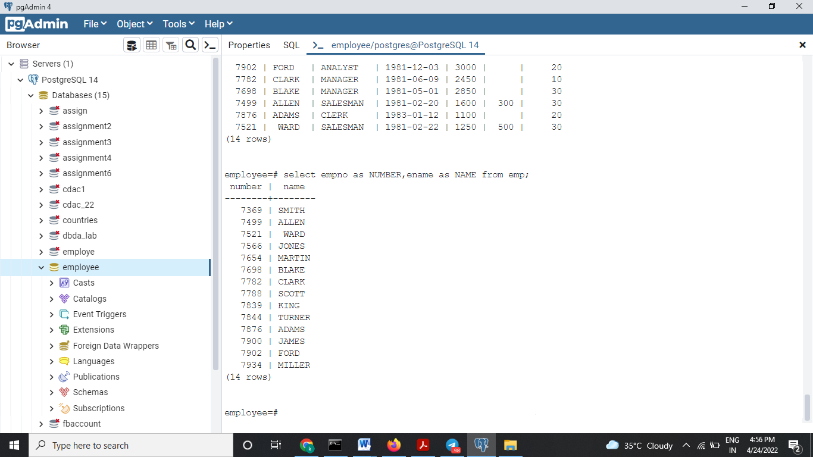

7. Find the names of all employees who were hired on the last day of the month

8. Find the name of the employee who is receiving the maximum salary.

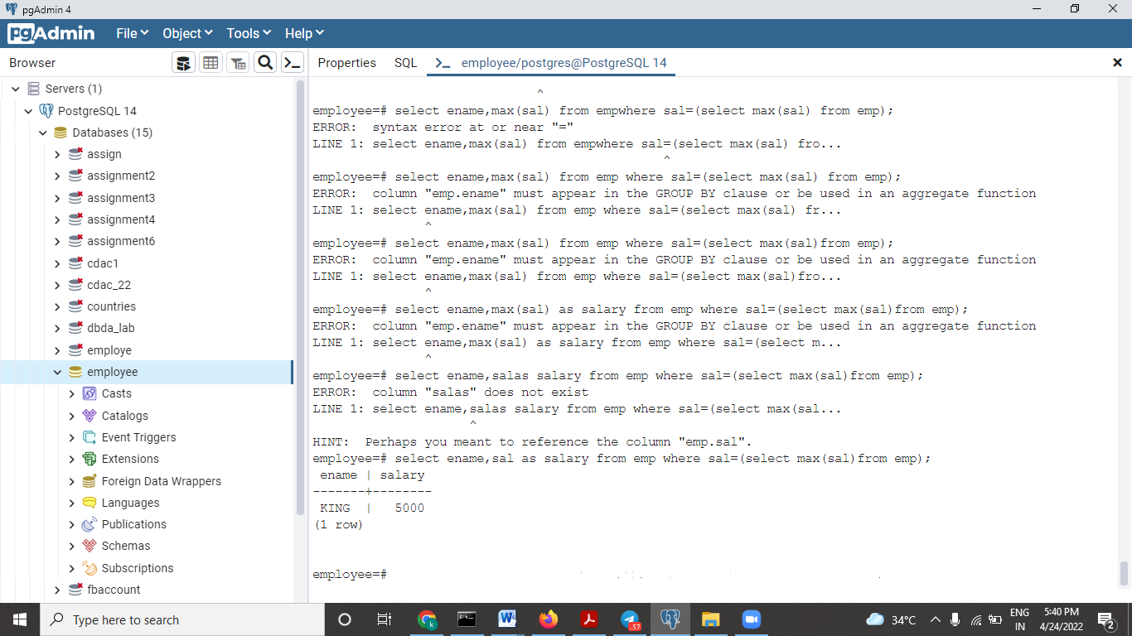

9. Display the sum of SAL for all the employees belonging to DEPTNO .

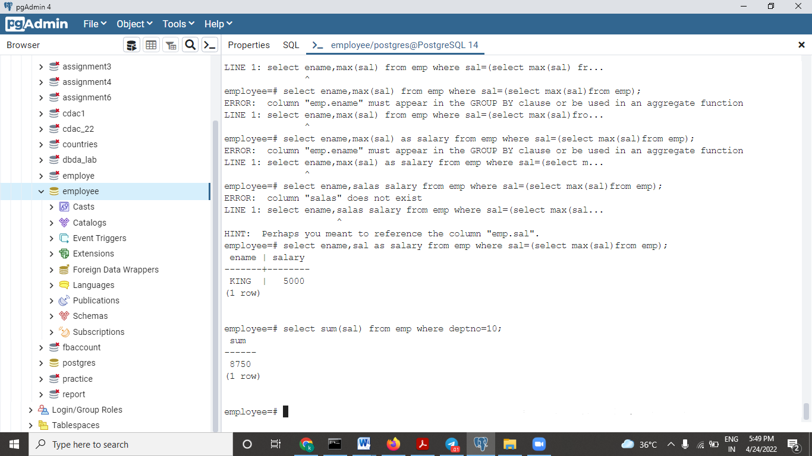

10. Display the rows where JOB column ends with the letter ‘T’.

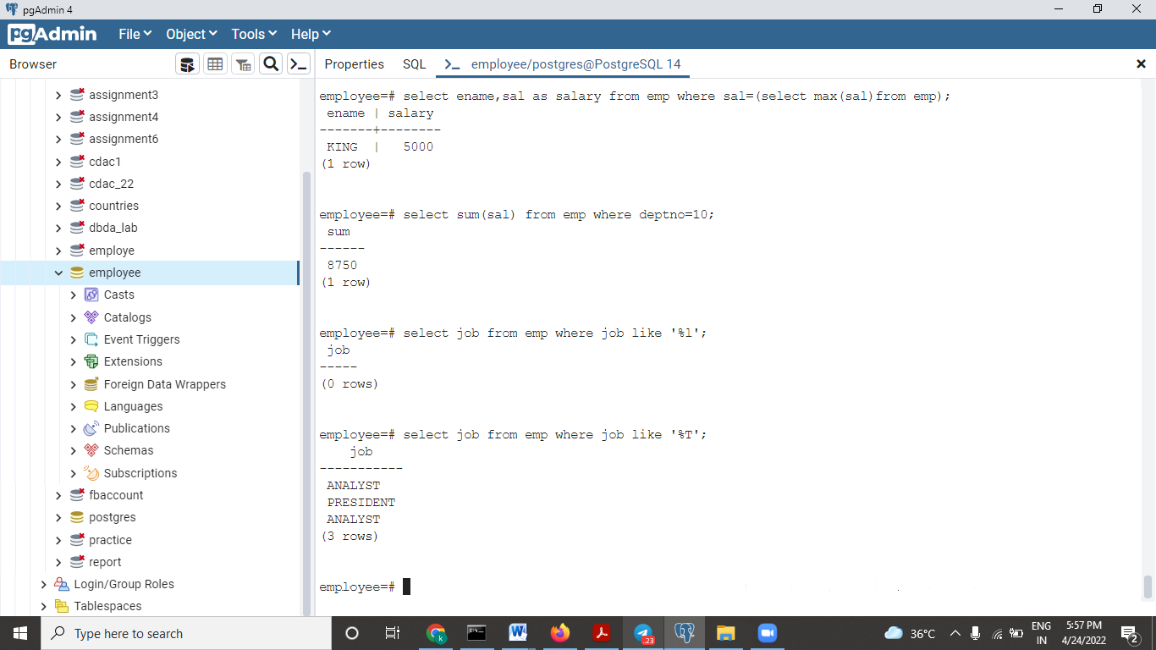

11Write a stored procedure to convert a temperature in Fahrenheit (F) to its equivalent in Celsius (C). The required formula is:- C= (F-32)*5/9 Insert the temperature in Centigrade into TEMPP table. Calling program for the storedprocedure need not be written.